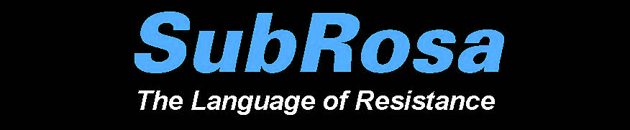

Title
Applying What You’ve Learned about José Toirac and Meira Marrero: Using Icons to Design an Installation

Concept/Main Idea of Lesson
The purpose of this lesson is to allow students the opportunity to design an installation art piece that utilizes icons and symbols. The design will reflect techniques and approaches featured in the art show SubRosa, with special emphasis on the work by Cuban artists José Toirac and Meira Marrero.

Intended Grade Levels
Grades 9-12

Infusion/Subject Areas
Visual Art
Social Studies

Curriculum Standards
Visual Art:
VA.68.S.2.3: Use visual-thinking and problem-solving skills in a sketchbook or journal to identify, practice, develop ideas, and resolve challenges in the creative process.
VA.68.S.2.1: Organize the structural elements of art to achieve artistic goals when producing personal works of art.
VA.68.O.1.3: Combine creative and technical knowledge to produce visually strong works of art.
VA.68.O.1.4: Create artworks that demonstrate skilled use of media to convey personal vision.
VA.912.S.2.6: Incorporate skills, concepts, and media to create images from ideation to resolution.
Social Studies:
S.912.H.1.2: Describe how historical events, social context, and culture impact forms, techniques, and purposes of works in the arts, including the relationship between a government and its citizens.
SS.912.H.1.5: Examine artistic response to social issues and new ideas in various cultures.
SS.912.H.2.1: Identify specific characteristics of works within various art forms (architecture, dance, film, literature, music, theatre, and visual arts).
SS.912.H.2.3: Apply various types of critical analysis (contextual, formal, and intuitive criticism) to works in the arts, including the types and use of symbolism within art forms and their philosophical implications.
SS.912.H.2.4: Examine the effects that works in the arts have on groups, individuals, and cultures.
SS.912.H.2.5: Describe how historical, social, cultural, and physical settings influence an audience's aesthetic response.

Instructional Objective
Students will:
- conceptualize a work of art using icons;
- apply techniques and approaches used in the art show SubRosa (with special emphasis on the work by Cuban artists José Toirac and Meira Marrero) to design an original piece of installation art;
- share their work with others;
- provide feedback to peers on their creations.

Learning Activities Sequence
Set Induction/Hook: Brainstorming: Have students take out a sheet of paper and writing instrument and tell them they will be participating in a timed, free-response exercise.
Step 1: Have students think about problems or injustices in the world and have
them jot down as many of them as they can. Tell them that no
answer is wrong; the more ideas, the better. (3 minutes)
Step 2: Ask students to review their lists, and cross out the least compelling
ideas. (1 minute)
Step 3: Instruct students to underline the three most significant problems or
Injustices on their list. (1 minute)
Step 4: Ask students to circle the most important problem or injustice to them.
(1 minute)

Class Discussion: Ask students to recall the works by Toirac and Marrero. What kinds of issues or problems were highlighted in the art work that you viewed? What icons and symbols did the artists use to convey their message?

Individual Reflection: At the top of a new sheet of paper, have students write the problem or injustice that they identified as most important. Have them consider icons, symbols, or images that they associate with the problem or injustice and write or sketch them under the heading.

Say: Today you will have the opportunity to design your own installation art to highlight a problem or issue you feel strongly about, using icons and symbols.

Project Design: Allow students enough time to design and sketch their projects, including a brief narrative of the issue, the techniques and materials used. Students will also prepare a budget for their installation, researching the estimated costs of the materials used.

Distribute Art Project Evaluation Rubric and explain each of the four components that will be assessed. Explain that in addition to creating artwork, artists must also take into account the cost of materials used to create their art, especially if they are seeking external funding.

Peer Feedback/Consultations: In pairs, students will have an opportunity to present their designs to a peer, explaining the concept behind the work, the techniques used, and the materials selected. Peers will provide feedback. The students will then switch roles so that each student will serve as both presenter and consultant.

Evaluation
Handout: Art Project Evaluation Rubric

Optional Extension Activities
Allow students to construct their designs and display them in the classroom or another venue in the school.

Materials and Resources
Art Project Evaluation Rubric
Computers and Internet for researching costs of materials
Calculator (for budget)

