Using the Sway Presentation
Why use Sway?
This presentation was designed in Sway to provide maximum flexibility to instructors. By using Sway, students have the ability to access the presentation and all reading and media files at their desk through a laptop, tablet, or cell phone. This allows instructors to teach activities and research in a combination of ways:
- Student groups of 3 with each student researching a different aspect of the Chernobyl disaster within the group (The Evacuation, The Impact on Health, The Propaganda)
- Student pairs with pairs being assigned a different aspect of the Chernobyl disaster (The Evacuation, The Impact on Health, The Propaganda)
- Student individual research with students addressing all aspects of the Chernobyl disaster
- Student class research with the class addressing all aspects of the Chernobyl disaster
How to use Sway?
Step 1: Open the Sway presentation by going to https://sway.office.com/IHe6EGUiZIis6UsW
OR
Insert the below visual link into your school’s Student Management System for students or an email.
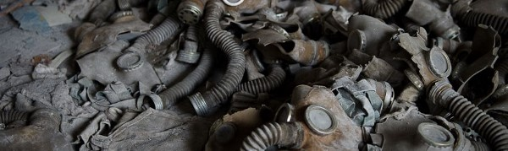
Return of the Real: Truth, History, & Chernobyl
How do historians and archaeologists determine what is real? In this lesson plan, students will examine the complexity of truths, realities, and perspectives of the Chernobyl nuclear disast…
Go to this Sway

Step 2: Play the Sway presentation by clicking PLAY at the top right corner of the screen.
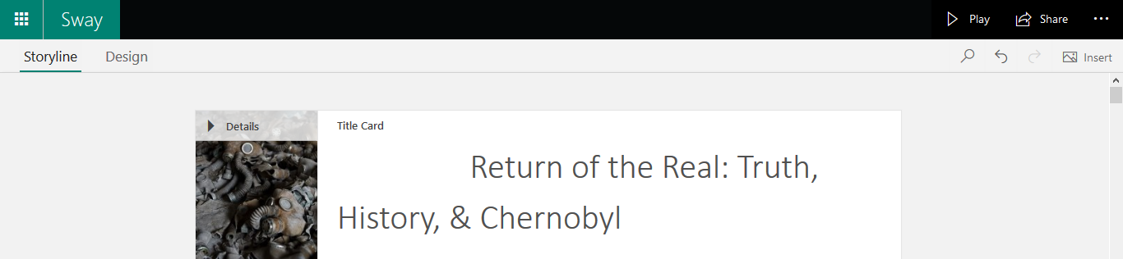

Step 3: Move through the Sway presentation using the icons in the bottom right corner of the screen.
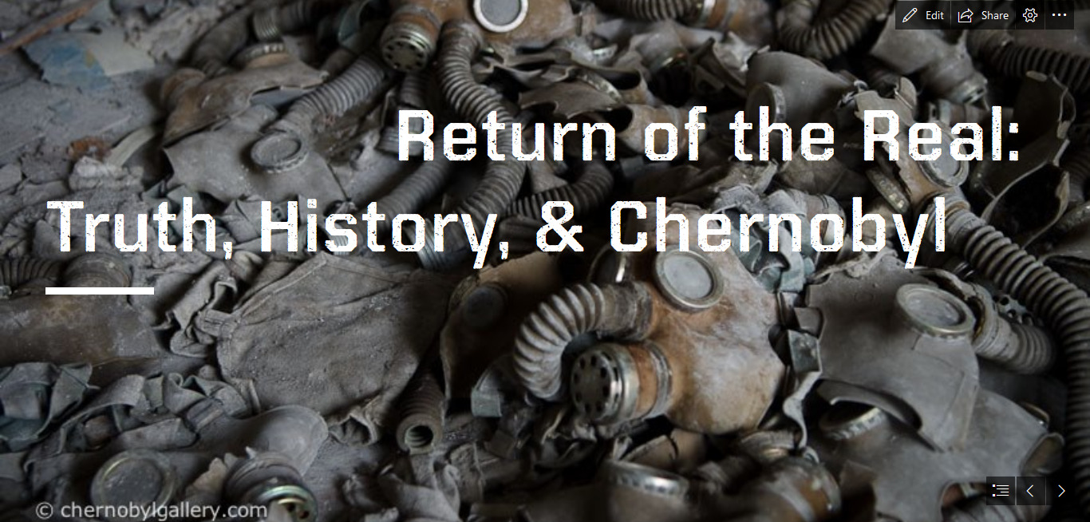
Navigate to a particular location in the presentation by clicking on the symbol. The click on the location you are interested in researching.
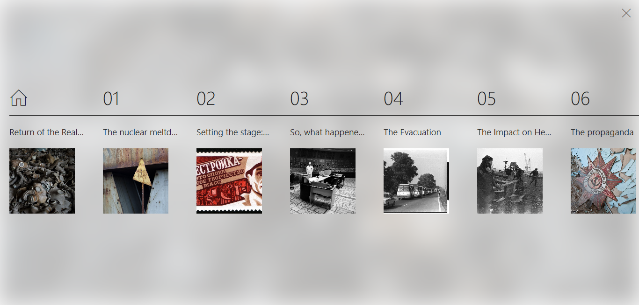

It’s that easy!

