Source: Detroit Institute of Arts, http://www.dia.org/portrait_studio/wall.html#
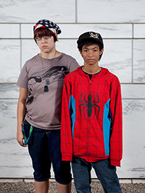
Taylor and Desha, Defend the DIA!, 2013 (printed 2014)
Taylor: “We’re both art students at CCS, so obviously the DIA has some importance to us. And plus, I personally love the DIA. I’ve been coming here since I was little, and it’s special to me so. And it has a big role on the city and a lot of the art students that are coming here or going to come here. I just hope they leave the DIA alone and don’t sell any of the art, just keep it the way it is. Detroit is a really good city, it’s lively. It’s just like, I feel like so many people think it’s, you know, this desolate place that doesn’t have any of its, you know, it’s culture or any of its, like, previous glory. It’s still a good city, it’s still full of life, and I just think people need to start, you know, coming down here more and give the city more life again and not just be afraid of ‘oh, you know if we go walking down the street, you know, we’re going to get shot.’ I’d like to, you know, maybe start a, like, an animation industry down here, hopefully to bring either money into city or, just like I said, make it more of like a visiting point. And I like it down here personally, I think it’s beautiful.”

